Nested for Loop

# Pyramid 1 :

<!DOCTYPE html>

<html lang="en">

<head>

  <meta charset="UTF-8">

  <meta name="viewport" content="width=device-width, initial-scale=1.0">

  <title>Pyramid Pattern</title>

  <style>

    .pyramid {

      text-align: center;

      font-family: Arial, sans-serif;

      white-space: pre;

    }

  </style>

</head>

<body>

  <div class="pyramid" id="pyramid"></div>

</body>

</html>

<script>

  function generatePyramid(rows) {

    let pyramid = '';

    for (let i = 1; i <= rows; i++) {

      for (let j = 1; j <= rows - i; j++) {

        pyramid += ' ';

      }

      for (let k = 1; k <= 2 * i - 1; k++) {

        pyramid += '*';

      }

      pyramid += '\n';

    }

    return pyramid;

  }

  document.getElementById('pyramid').textContent = generatePyramid(5);

</script>

# OutPut :

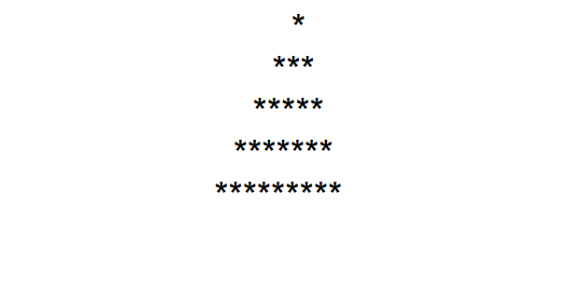

# Pyramid 2 :

<!DOCTYPE html>

<html lang="en">

<head>

  <meta charset="UTF-8">

  <meta name="viewport" content="width=device-width, initial-scale=1.0">

  <title>Document</title>

</head>

<body>

  <script>

    let rows = 5; // You can change this value for different sizes

    for (let i = rows; i >= 1; i--) {

      let output = "";

      for (let j = 1; j <= i; j++) {

        output += "* ";

      }

      // Create a new paragraph element and append it to the body

      let p = document.createElement("p");

      p.textContent = output;

      document.body.appendChild(p);

    }

  </script>

</body>

</html>

# OutPut :

